**Fixed Deposit Account Errors at the End of Nov 2016:**

1. The New Fixed Deposit not show **Interest Rate** and **Maturity Date** at CNC:

* Customer ID: 4000052936
* Customer Acc: 460000024938
* Customer Name: HIM DIMONG
* Open Date: 28/11/2016
* Amount: KHR 5,160,000

Listing:

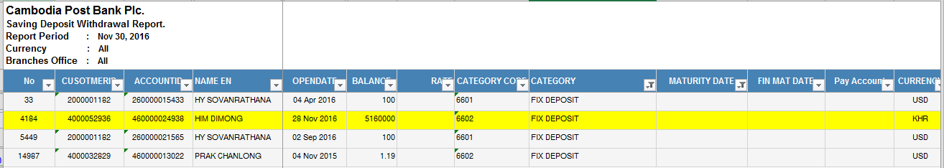

Find Deposit:

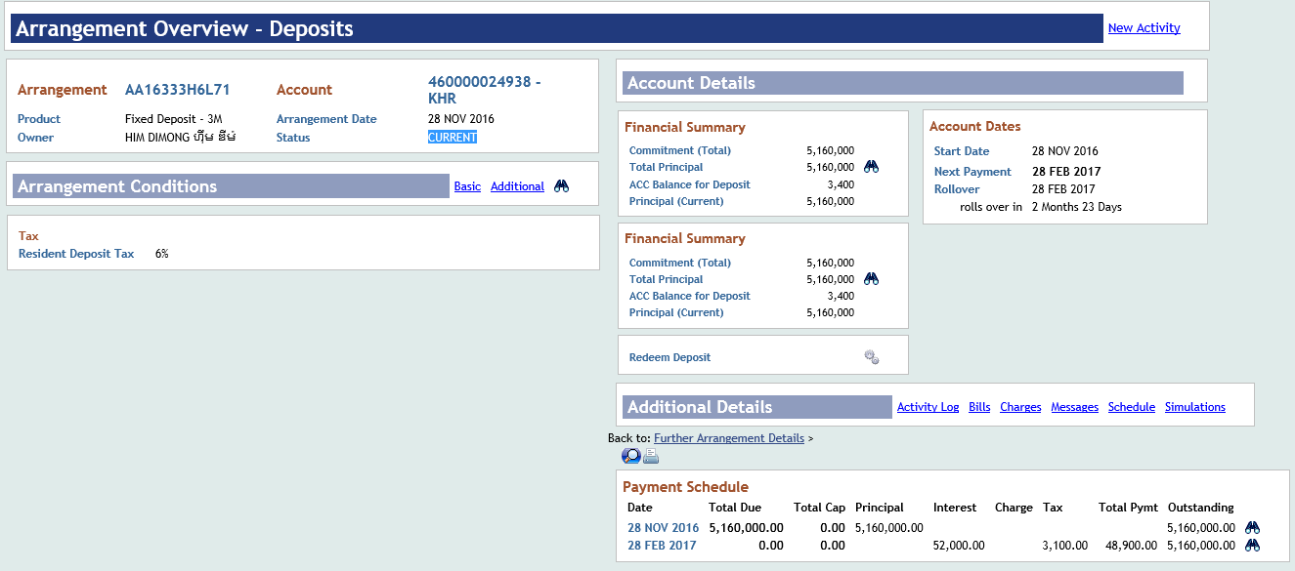

Acc. Statement:

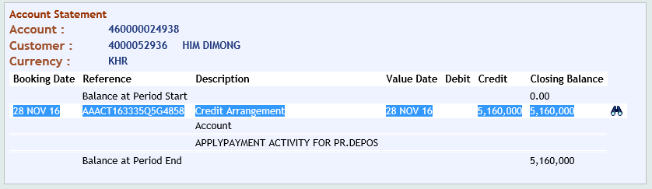

1. The Old Account is over Maturity Date auto change to “CURRENT” Status at OLP:

Customer ID: 4000032829

Customer Acc: 460000013022

Customer Name: PRAK CHANLONG

Open Date: 04 Nov 2015

Maturity Date: 04 May 2016 (6M)

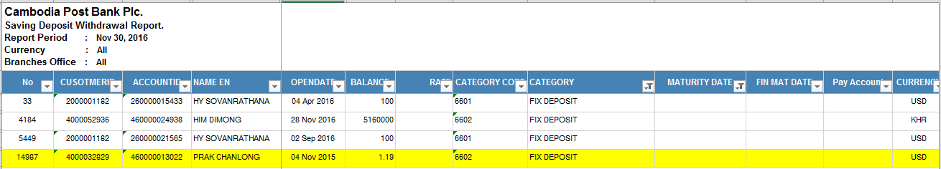

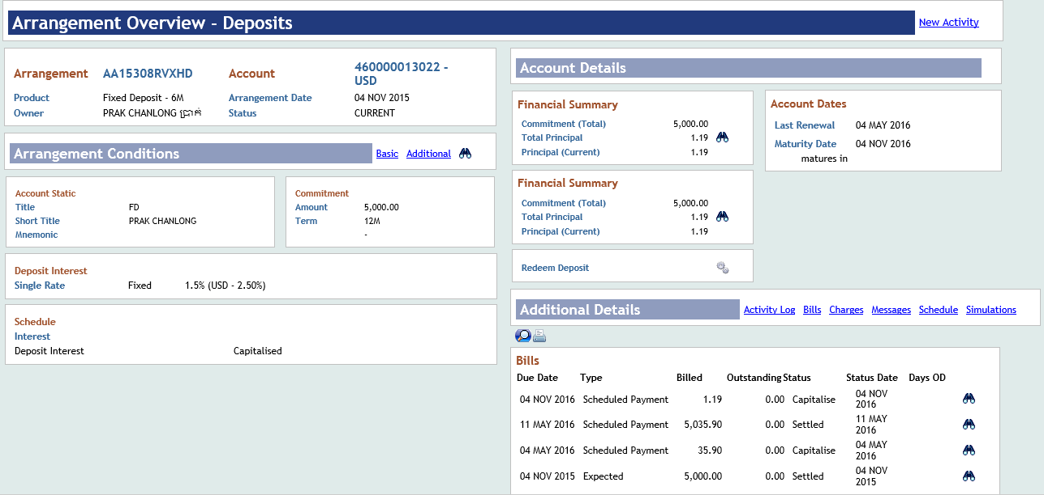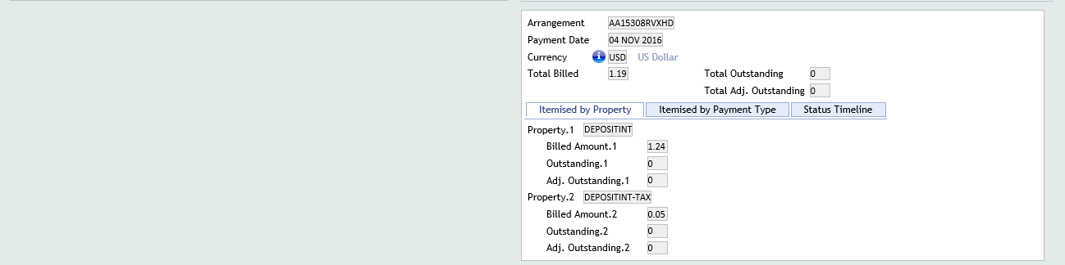

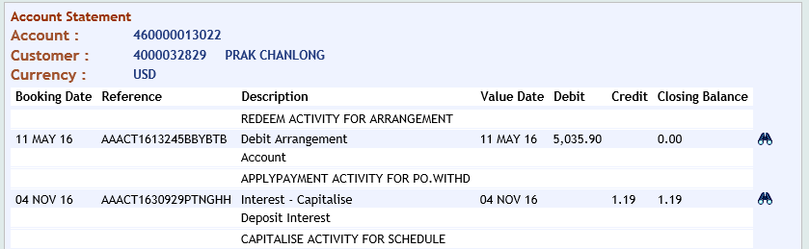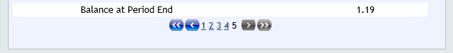

**5637-323130-Long Term – Time Deposits – Individuals – Resident**

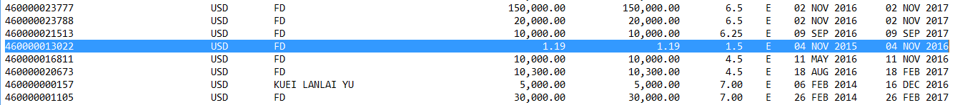

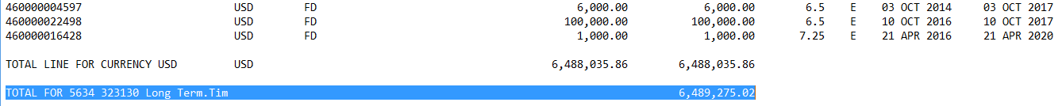

1. Two accounts of Fixed Deposit is over maturity date and Expired status at OLP:

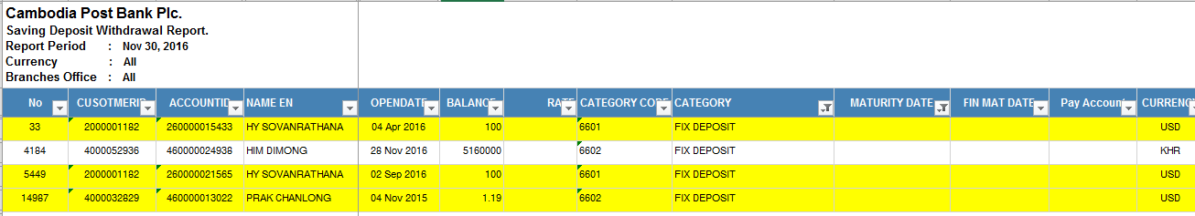

* Customer Name: HY SOVANRATHANA

Customer ID: 2000001182

Account Number: 260000015433

Maturity Date: 04 Oct 2016

Account Status: EXPIRED

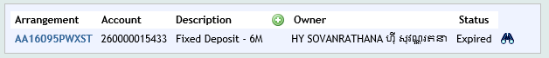

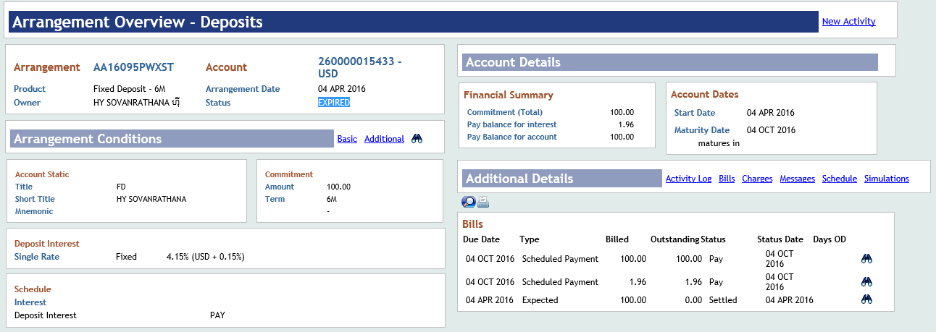

Account Statement:

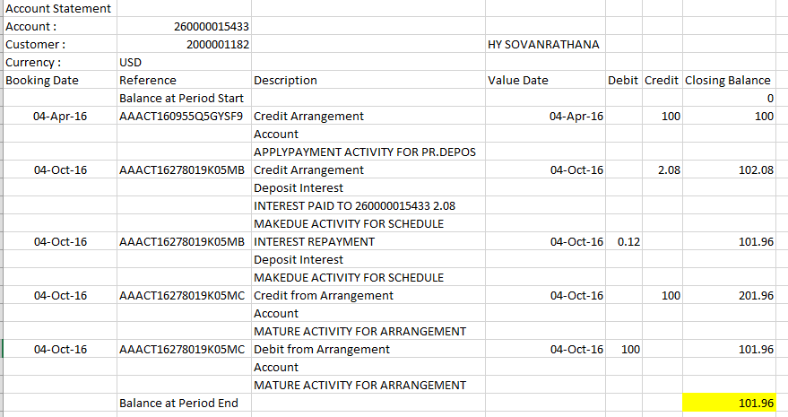

* Customer Name: HY SOVANRATHANA

Customer ID: 2000001182

Account Number: 260000021565

Maturity Date: 04 Oct 2016

Account Status: EXPIRED

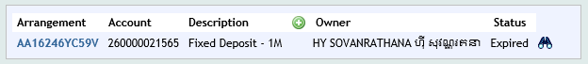

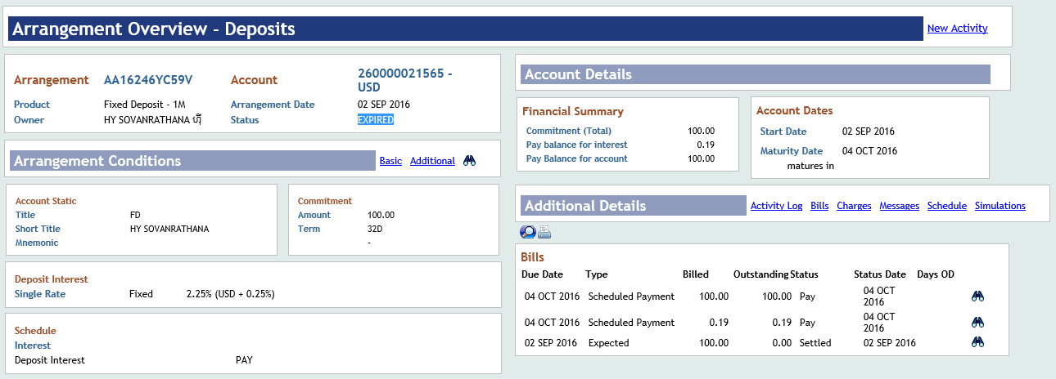

Account Statement:

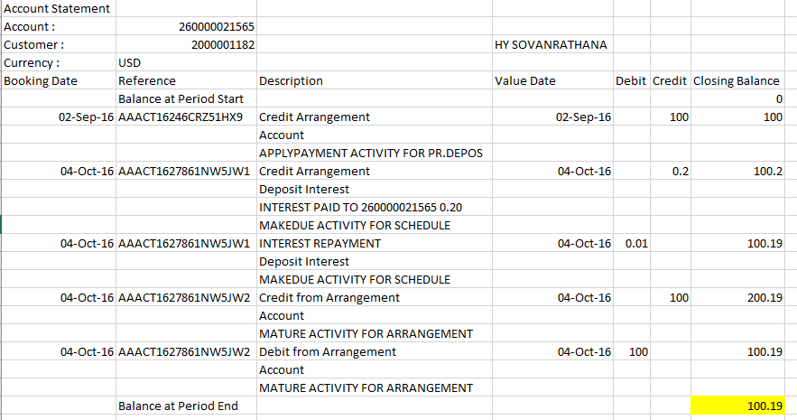

1. Fixed Deposit Error at CNC is over Maturity Date but Not Close and show “Minus Balance”

* **Customer Name: CHIN SAROEUN**
* **Customer Account: 460000017931-Fixed Deposit**
* **Customer ID: 4000041412**
* **Account Status: Closed**
* **Leger Balance: 0.00**
* **Working Balance:** -60,909.51

Account Status:

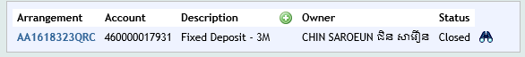

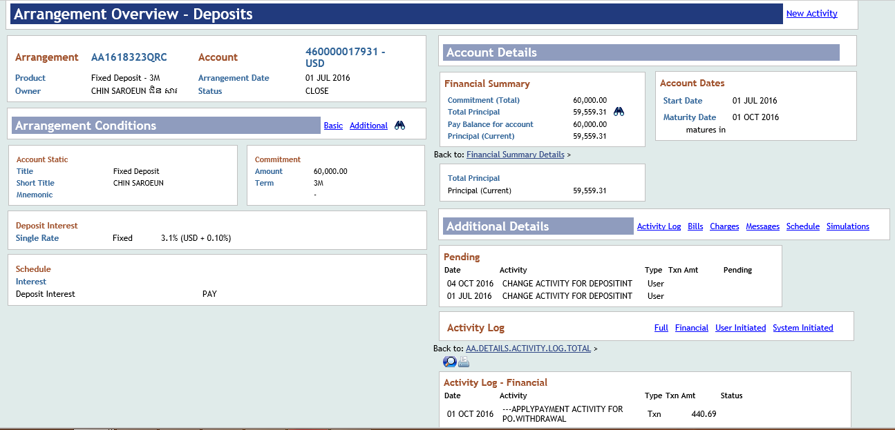

Balance Summary:

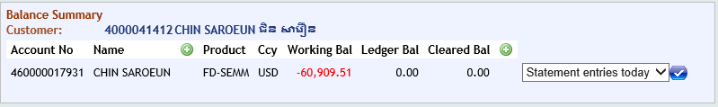

7992-951000-Commitment to Sell Precious Metals

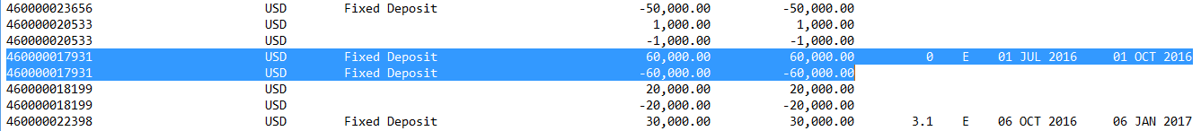

Fixed Deposit Account: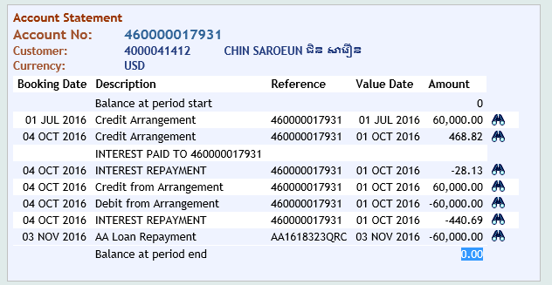

Saving Account:

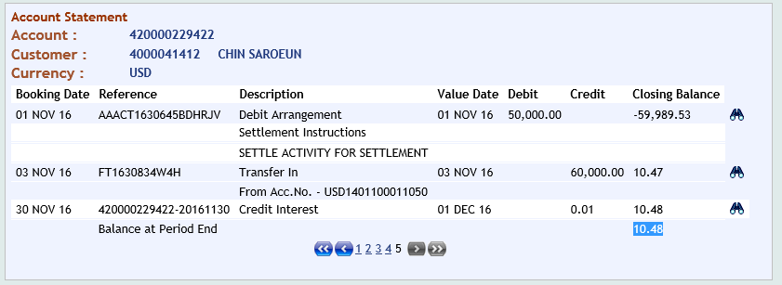

1. Fixed Deposit is over Maturity Date but still Pending amount in GL at OLP:

Customer ID: 2000009173

Customer Acc.: 260000012078

Customer Name: TANG MOUYLENG

Maturity Date: 01 Jun 2016

Account Status: Closed

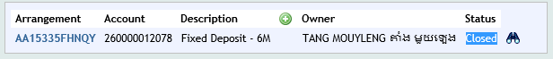

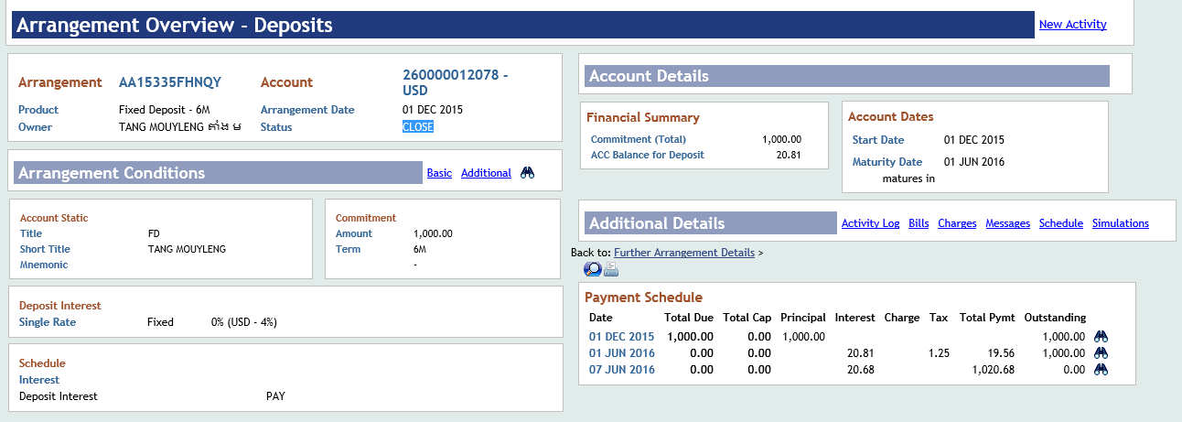

6538-344330-AIP-Long Term-Time Deposit-Individuals-Resident



7992-951000-Commitment to Sell Precious Metals



Fixed Deposit Account:

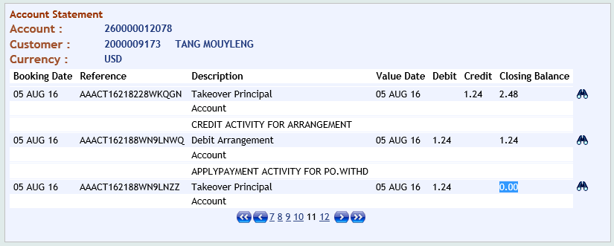

Saving Account:

